21.54: By superposition we can add the electric fields from two parallel sheets of charge.
a) 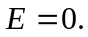
b)
c) 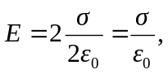 directed downward.

